Evolution and Adaptations

A. Introduction
- We know from everyday experience that an organism can adapt to its environment (for example, a plant grows toward the light it needs for photosynthesis).
- In contrast, when biologists talk about evolution, they often use the term adaptation to refer to a more stable heritable characteristic that contributes to the ability to survive and reproduce (e.g. the camouflage color of many mammals' fur).
- Biologists use the term phenotypic plasticity to refer to the ability of an individual to adapt to different environments. A phenotypic characteristic is any observable characteristic of an organism (e.g. shape or color) and plasticity means that, during an organism’s lifetime, the phenotypic characteristic can change in response to the environment.

You will see in this activity that:
- Phenotypic plasticity can be a heritable trait that can contribute to fitness (the ability to survive and reproduce). Thus, phenotypic plasticity can be an adaptation.
- Phenotypic plasticity, like other adaptations, can become more common in a population as a result of natural selection.

1. If you have ever grown a plant on a windowsill, you may have noticed that the plant tended to grow toward the light coming in the window. Thus, the plant had phenotypic plasticity in shape in response to light in the environment. How could this type of phenotypic plasticity contribute to greater fitness for a plant growing in nature?

B. Contributions of Phenotypic Plasticity to Fitness – Cephalopod Camouflage
Cephalopods include octopus, squid, and cuttlefish. To learn about cephalopod camouflage, view the video at https://www.youtube.com/watch?v=eS-USrwuUfA.

2. Describe cephalopod camouflage and explain how it differs from camouflage in most other types of animals.

3a. Complete this table to describe how cephalopod camouflage satisfies the criteria for phenotypic plasticity.
Phenotypic characteristic (or characteristics)

How do these phenotypic characteristics change in response to the environment?

3b. How does phenotypic plasticity in color, pattern and texture of the body surface contribute to the fitness of an octopus?

4. Some species of cephalopods can produce more complex visual camouflage because they have more chromatophores per square millimeter of body surface and more brain tissue devoted to chromatophore control. Would the ability to produce complex patterns of visual camouflage be expected to contribute more to fitness for:
___ a species of cephalopod that is active at night or
___ a species of cephalopod that is active during the day?

___ a species of cephalopod that lives on coral reefs or rock reefs or
___ a species of cephalopod that lives in more uniform environments and cloudy water?
Explain your reasoning.

Available evidence supports the hypothesis that a greater ability to produce complex visual camouflage is observed in species of cephalopods with a lifestyle and habitat where excellent visual camouflage would be expected to make a greater contribution to fitness.

C. Why do some Daphnia show phenotypic plasticity in pigmentation?

Daphnia (water fleas) include multiple species of small crustaceans that swim in freshwater ponds and lakes and feed on small algae and other particles suspended in the water.  In this section, we will investigate a species of Daphnia that lives in mountain lakes in California. Some of these Daphnia have a transparent carapace (outer covering), but others have a darker carapace because of melanin (a dark pigment) deposited in their carapace. | The antennae are used for swimming. Actual size is only 4-5 mm; this is one of the largest species of Daphnia (figure from http://pulse.pharmacy.arizona.edu/9th_grade/culture_cycles/science/bioassay.html)

Daphnia from lakes with no fish show phenotypic plasticity in pigmentation.
We will begin by discussing Daphnia from lakes that do not have fish and historically have never had fish. For Daphnia from lakes with no fish, the major advantage and disadvantage of producing more melanin are:
Advantage of Producing More Melanin | Disadvantage of Producing More Melanin
- Melanin absorbs UV light which can damage DNA. Therefore, melanin in the carapace protects the Daphnia’s cells and any developing eggs against damage due to UV light. | - It takes energy and resources to produce melanin, so Daphnia that produce melanin take longer to reach sexual maturity and begin reproducing.

5. Use this information to complete the following table for Daphnia from lakes with no fish.

Amount and pattern of UV light in the environment | Optimum  Pigmentation* | Why would this pigmentation increase the fitness of Daphnia exposed to this amount and pattern of UV light?
A lot throughout the year and in all locations

A lot in some seasons and locations and
very little in other seasons and locations

*Choose the best match from the following:
a. a lot of melanin in the carapace
b. very little melanin in the carapace
c. adjustable each time the Daphnia molts, with less melanin in the carapace when exposed to more UV light
d. adjustable each time the Daphnia molts, with more melanin in the carapace when exposed to more UV light

Since the amount of UV light varies in different seasons and locations in these lakes, researchers predicted that the Daphnia would show phenotypic plasticity in the amount of melanin in the carapace, depending on the amount of UV light. Laboratory experiments with clones of Daphnia from lakes with no fish have confirmed this prediction.

Differences between Daphnia from lakes with and without fish.
The same researchers tested for phenotypic plasticity in pigmentation for Daphnia taken from lakes that had been stocked with fish 50-90 years before the research study. These fish hunt visually, and darker Daphnia are more likely to be seen and eaten.

6. Complete the following table to describe the advantage and disadvantages of producing more melanin for Daphnia in lakes with fish.

Daphnia from: | Advantage  of producing more melanin | Disadvantages  of producing more melanin
Lakes with no fish | - Reduces damage due to UV light | - Slower development
Lakes with fish

7. The researchers found the following results for Daphnia from lakes with no fish vs. lakes with fish.
Clones of Daphnia from: | Amount of melanin in carapace  if raised in the laboratory with: |  | Do these Daphnia show  phenotypic plasticity  in melanin production?
 | Exposure to UV Light | No UV light
Lakes with no fish | High | Moderate
Lakes with fish | Low | Low | No

Complete the last column.

The differences in phenotypic plasticity between the clones of Daphnia from lakes with vs. without fish must be due to genetic differences, since the researchers raised and tested the clones of Daphnia in the laboratory under identical conditions (except that half of each clone of Daphnia were exposed to UV light as they developed and half were not).

8. Based on this evidence, scientists believe that, after a lake was stocked with fish, natural selection acted against Daphnia that had phenotypic plasticity in melanin production and instead favored Daphnia that had consistently low levels of melanin production. Propose a hypothesis to explain why, in lakes with fish, natural selection favored consistently low production of melanin instead of phenotypic plasticity in melanin production. How could phenotypic plasticity in pigmentation decrease fitness for Daphnia in lakes with fish?

D. Natural selection can increase phenotypic plasticity in Daphnia behavior.

In this section we will discuss a different species of Daphnia that lives in ponds in Europe. These
Daphnia have a different way of avoiding fish predation. Since the fish that eat these Daphnia swim near the surface of the water, the Daphnia can reduce fish predation by swimming lower in the water when fish are present.  When there are no fish in a pond Daphnia benefit from swimming closer to the surface where there is more food and more warmth, both of which promote more rapid growth. | 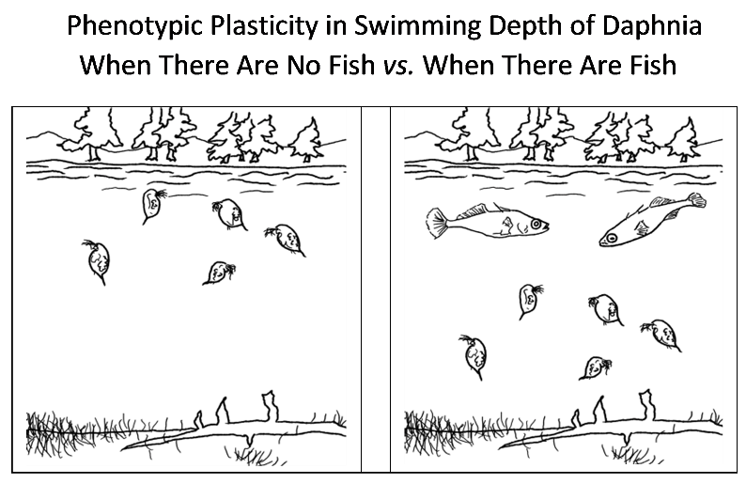

9. Complete the following table to predict where Daphnia will swim, depending on the amount of fish predation.

Amount and pattern of fish predation | Optimum swimming depth of Daphnia* | Why would this swimming depth (or change in swimming depth) increase the fitness of the Daphnia under these conditions?
No fish predation at any time of year

Fish predation varies in different seasons (e.g. higher in the summer)

*Choose the best match from the following:
a. always swim high in the water near the surface
b. always swim lower in the water
c. swim lower in the water when there are no fish, but swim near the surface in response to fish smell
d. swim near the surface of the water when there are no fish, but swim lower in the water in response to fish smell

To test these predictions, researchers studied Daphnia in a man-made pond where levels of fish predation on Daphnia were low in the early years (1970-2). Then, beginning in 1973, the pond was stocked with lots of Daphnia-eating fish and levels of fish predation were high, especially in the summer. Their study found:
Proportion of clones that: | Descendents of Daphnia from:
 | 1970-2, when there was  little predation by fish | 1976-9, when there was  a lot of predation by fish
– Consistently swam near the surface of the water | 90% | 10%
– Showed phenotypic plasticity (swimming lower in the water in response to fish smell) | 10% | 60%
– Consistently swam low in the water | 0% | 30%

10. Complete this table to show that phenotypic plasticity in swimming depth in response to fish smell is a trait that meets the requirements for natural selection.
Requirement for Natural Selection | Evidence that Phenotypic Plasticity in Swimming Depth in Response to Fish Smell Meets This Requirement
Variation in the trait

Heritability of variation in the trait | For Daphnia raised under identical laboratory conditions, some clones of genetically identical Daphnia showed phenotypic plasticity in swimming depth and other clones did not; these differences between clones must be due to genetic differences.
Differences in the trait influence fitness.

11. How did natural selection increase the proportion of Daphnia with phenotypic plasticity in swimming depth? (Hint: Think about what happened to the Daphnia without phenotypic plasticity in swimming depth when more Daphnia-eating fish were introduced, beginning in 1973.)

This example illustrates that phenotypic plasticity (the ability to adapt to different environments within an individual's lifetime) can be an adaptation (a heritable characteristic that has become common in the population as a result of natural selection). In general, phenotypic plasticity can be an adaptation that optimizes fitness for some organisms that live in variable environments.
E. General Conclusions about Evolution

12. How does the research on Daphnia help to counteract the following misconceptions about evolution?

- The fittest organisms in a population are those that are strongest, healthiest, fastest and/or largest.

- Evolution only occurs slowly.

- Natural selection produces organisms perfectly suited to their environment.

This activity was written by Drs. Ingrid Waldron and Jennifer Doherty, Department of Biology, University of Pennsylvania, © 2013. This Student Handout and Teacher Notes are available at http://serendipstudio.org/exchange/bioactivities/evoadapt.

Daphnia females reproduce asexually and produce clones of genetically identical female offspring. Half of each clone of genetically identical, laboratory-raised Daphnia were raised in UV light and half were raised with no UV light. Differences in their carapace pigmentation demonstrated phenotypic plasticity in response to UV light. Notice that phenotypic plasticity can be thought of as the ability of a single genotype to produce different phenotypes in response to different environmental conditions, either within an individual's lifetime or for different individuals that have the same genotype.

